Suggested template

CONFERENCE LETTERHEAD

Thursday, 26 January 2017

To whom it may concern:
Peer-review process / confirmation

(1) On behalf of [Name of Conference] – the manuscript(s) listed hereunder were accepted for oral presentation:
List of papers
Conference venue (city and country):
Conference date:

(2) We confirm that the manuscripts were peer-reviewed by two (2) or more technical specialists. The review process is conducted anonymously.

(3) The manuscripts were accepted for oral presentation.

(4) At the conference, the conference proceedings (with ISBN) will be provided; the manuscripts will be published via the proceedings.

(5) This conference does not provide formalised peer-review reports (PRR); in case no commentary has been provided – then this letter attests that the peer-review process (PRP) yielded in acceptance of the article – without further changes.

Regards,

______________________
Conference Manager/Organiser
E-mail address: ________@___________

Example letter

CONFERENCE LETTERHEAD

Thursday 4 August 2016

To whom it may concern:
Peer-review process / confirmation
(1) On behalf of IEEE CAS 2016 - International Semiconductor Conference – the manuscripts listed hereunder were accepted for oral presentation:
M. Fanoro, S. S. Olokede and S. Sinha, “Investigation of the Effect of Input Matching Network on 60 GHz Low Noise Amplifier,” Proceedings: 2016 IEEE International Semiconductor Conference, 10-12 Oct. 2016, Sinaia, Romania.
J.S.L. van Niekerk and S. Sinha, “A 2.5 GHz Low Phase Noise Silicon Germanium heterojunction Bipolar Transistor Ring Oscillator,” Proceedings: 2016 IEEE International Semiconductor Conference, 10-12 Oct. 2016, Sinaia, Romania.
S. Chaturvedi, M. Božanić and S. Sinha, “Effect of Lossy Substrates on Series Impedance Parameters of Interconnects,” Proceedings: 2016 IEEE International Semiconductor Conference, 10-12 Oct. 2016, Sinaia, Romania.
(2) We confirm that the manuscripts were reviewed by more than two (2) technical specialists – in some cases up to five (5) technical specialists. The review process is conducted anonymously.
(3) The manuscripts were accepted for oral presentation.
(4) At the conference, the conference proceedings will be provided; the manuscripts will be published via the proceedings.
Regards,

Cristina Buiculescu – IMT Bucharest, Romania
Conference Manager
On behalf of IEEE CAS 2016
cas@imt.ro

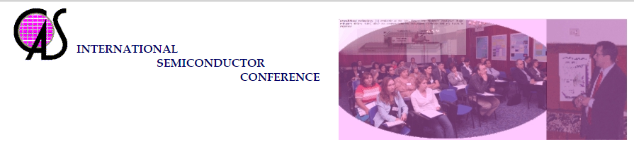ADVISORY COMMITTEE
G.A.J. Amaratunga - Cambridge Univ., UK
N. Barsan - Tuebingen Univ, Germany
S Bellucci – INFN Laboratory Nazionali di Frascati, Roma, Italy
C. Bulucea* - National Semiconductor, CA, USA
S. Cristoloveanu - CNRS-INPG-UJF, Grenoble, France
H. Hartnagel - Techn. Univ. Darmstadt, Germany
A.M. Ionescu - EPF, Lausanne, Switzerland
G. Konstantinidis - FORTH Heraklion, Greece
R. Marcelli - CNM, Rome, Italy
S. Melinte - Univ. Catholique de Louvain, Belgium
J. Millán - CNM-CSIC, Barcelona, Spain
K. Mutamba - Infineon Technologies, Germany
L. Pavesi - Univ. of Trento, Italy
R. Plana - LAAS-CNRS, Toulouse, France
A. Tugulea – Romanian Academy
F. Udrea - Cambridge Univ., UK
TECHNICAL PROGRAM COMMITTEE
Gh. Brezeanu - “Politehnica” Univ. of Bucharest, Romania
M.L. Ciurea – INCD - FM*, Bucharest, Romania
D. Cristea – IMT Bucharest, Romania
D. Dascalu – IMT Bucharest, Romania
M. Dragoman – IMT Bucharest, Romania
D. Dobrescu - “Politehnica” Univ. of Bucharest, Romania
A. Müller – IMT Bucharest, Romania
R. Müller – IMT Bucharest, Romania
D. Neculoiu – IMT Bucharest, Romania
- Technical Program Vice Chair:
Gh. Brezeanu - “Politehnica” Univ. of Bucharest, Romania
M. Dragoman – IMT Bucharest, Romania
